**Mutex Property:**

A[] not (g11.Green && nust.Green && airport.Green && islamabad.Green)

**Mutex Property Verification:**

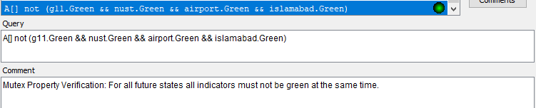

**Bounded Liveness Properties:**

E<> g11.Green

E<> airport.Green

E<> nust.Green

E<> islamabad.Green

**Bounded Liveness Properties Verification:**

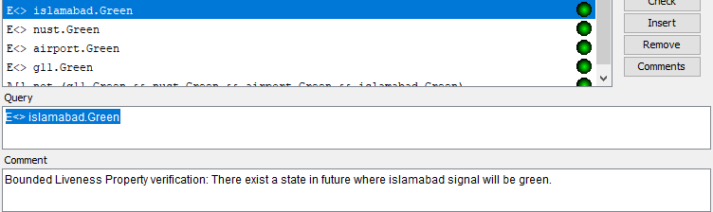

**Bounded Liveness Properties:**

A[] not (g11.Red && nust.Red && airport.Red && islamabad.Red)

**Bounded Liveness Properties Verification:**

